**CST8257 Web Application Development**

Lab 1

# Objective

Install and configure a PHP Integrated Development Environment.

# Credit and Due Date

This lab is the most important lab in this course. Without completing this lab, you will not be able to run class examples and proceed to the subsequent labs. You should complete this lab before the second lecture of the course.

To earn 5 points, you are required:

1. Complete the lab as required.
2. Demonstrate your lab work before the due date.

# Background

Any PHP development environment has to contain the following components:

1. A Web Server, also known as HTTP Server, to serve the HTTP requests from clients
2. A PHP script engine to dynamically generate HTML per given PHP scripts
3. A database, almost all dynamic web applications will have a database
4. A text editor/organizer for editing, generating/suggesting and syntax checking source code
5. File organizer to organize multi-source-file applications into projects.
6. A Debugger for testing and debugging the source code.
7. A PHP web application framework providing code templates, application scaffolding and class/function libraries. It is not necessary to have a framework for developing small to midsize web applications.

In ASP.NET development environment where all components are from Microsoft and integrated into one single product; Visual Studio, you only have to install Microsoft Visual Studio. In contrast, in PHP development “eco-system”, the components come from different vendors, and for each components, there are a variate of competing choices. You will have to install them individually and configure to integrate them to work as an Integrated Development Environment.

**Note:** By installing **PHP Tools for Visual Studio** extension, you can use Visual Studio as an effective IDE (less MySQL database integration) for PHP Web application development. We choose not to use Visual Studio in this course for the following reasons:

1. PHP Tools for Visual Studio is not free, you may have to pay after the 30-day trial period.
2. If an organization choose to use PHP as its server-side technology, more likely, the organization does not possess licences for Microsoft Visual Studio. If you join such organizations, you will not have Visual Studio at your disposal.
3. To broad your knowledge and skills of website development environments.

However, for whatever reason, you would rather stick with Microsoft Visual Studio, you can follow **Appendix A – Setup Visual Studio for PHP development**.

# Install AMPPS Package

AMPPS package is a software bundle including the following individual components

* Apache HTTP Server
* PHP Script Engine
* MySQL Database

**Note**: There are many such packages which bundle all three components, such as XAMP, WAMP, etc. If you prefer, you can use any of these packages.

1. Download the most recent version of AMPPS from: <http://www.ampps.com>
2. After installation, you can start AMPPS by run Ampps.exe in the AMPPS’ installation folder. Once started, you will see an AMPPS control panel:

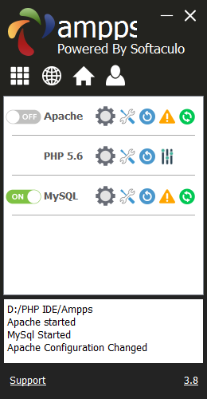

1. Change port number

You may encounter the following error message when starting the Apache Web Server:

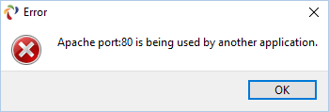

It is because a port number can only be bound to one service/application at a time. If the port number 80 has been used by another program, most likely by Microsoft IIS, Apache will not be able to start. You have the following two choices:

* + - Stop IIS
    - Bind Apache to another port number, e.g. 8080

To bind Apache to a different port, edit the Apache’s configuration file **httpd.conf** follow the screen captures below:

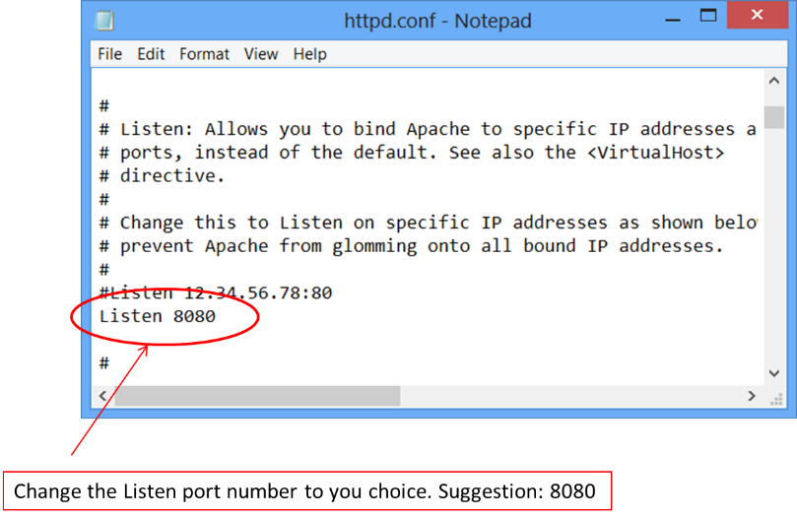

Save the change to the Apache configuration file and try to start Apache again. You may be prompted to open your firewall to allow Apache to penetrate the firewall.

If you encounter the following error message:

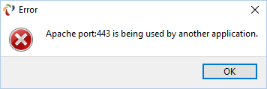

You have to edit Apache’s configuration file again to comment out the following line:

LoadModule ssl_module modules/mod_ssl.so

That is to change the line to:

#LoadModule ssl_module modules/mod_ssl.so

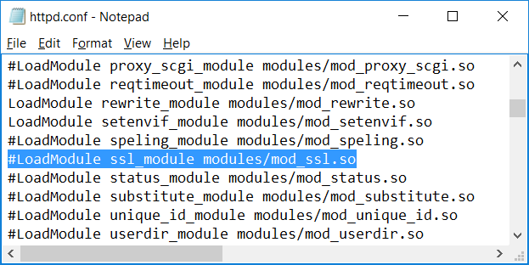

1. Change PHP Version

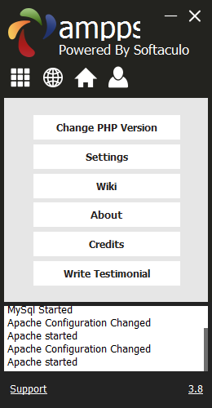 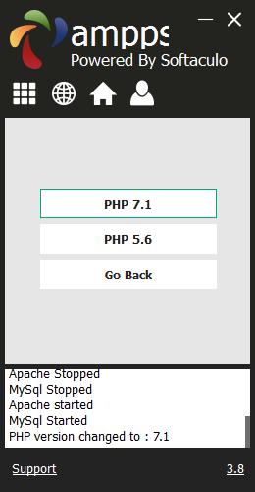 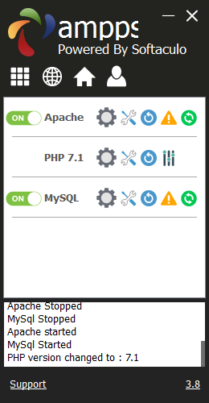

1. Verify your installation

* Once started Apache successfully, start a browser of your preference and go to the installed AMPPS’ home page at:

<http://localhost:8080/ampps/index.php>

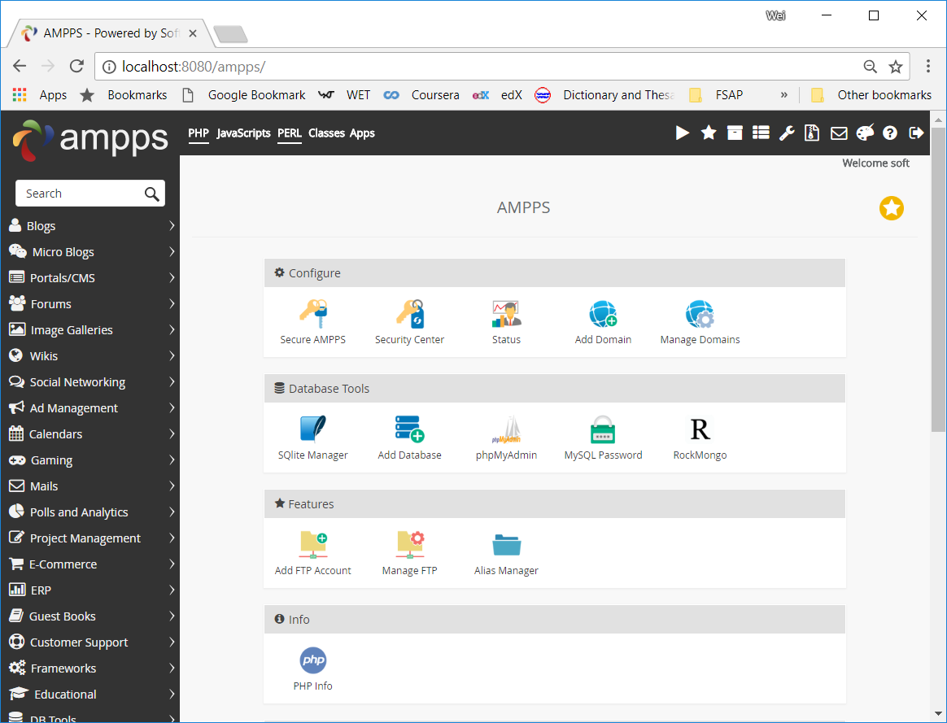

* By default Apache’s document root is **www** folder in its installation folder (in my installation, it is D:\PHP IDE\Ampps\www). Use your preferred text editor to create a php file **phpinfo.php** containing a single line:

<?php phpinfo(); ?>

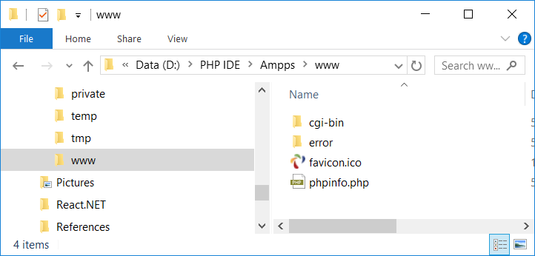

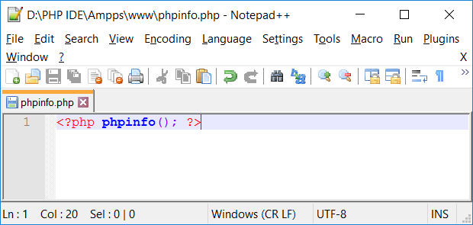

**Note**: phpinfo( ) is a build-in function defined in PHP script engine, it returns detailed information about the php installation on the host.

* Start your preferred browser and go to page: <http://localhost:8080/phpinfo.php>

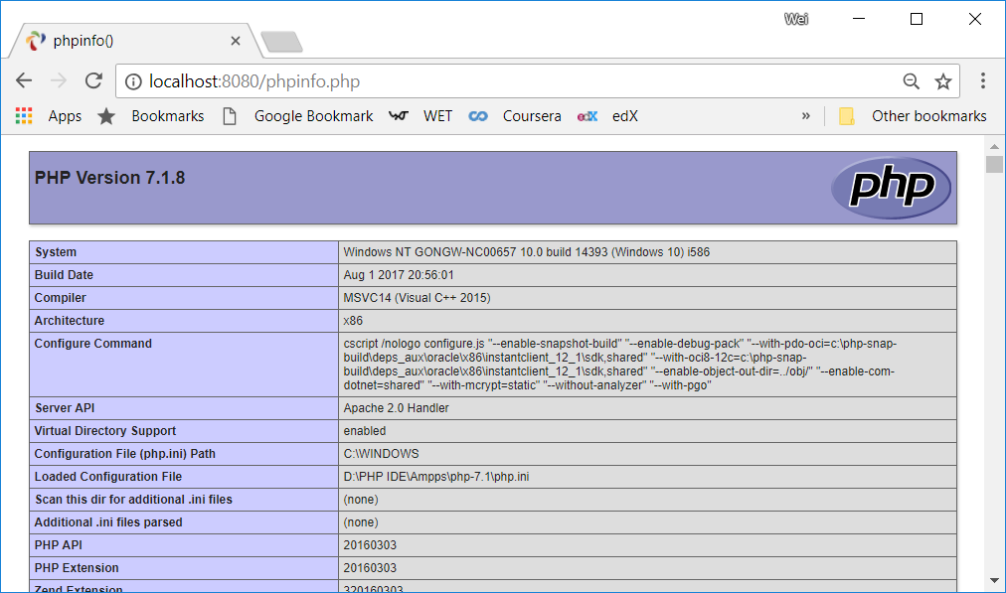

# Install XDebug

The best way to find out the version of XDebug you need download is to let **xdebug.org** find out for you.

1. Go to website: <https://xdebug.org/wizard.php>
2. Copy the entire page <http://localhost:8080/phpinfo.php> as displayed in the browser at step 5 of Install AMPPS above (ctrl-A and ctrl-C) into the text box and click button **Analyze my phpinfo( ) output**.

The analysis result will be displayed telling you exact what to download and how to install in your particular AMPPS installation as shown below for my installation:

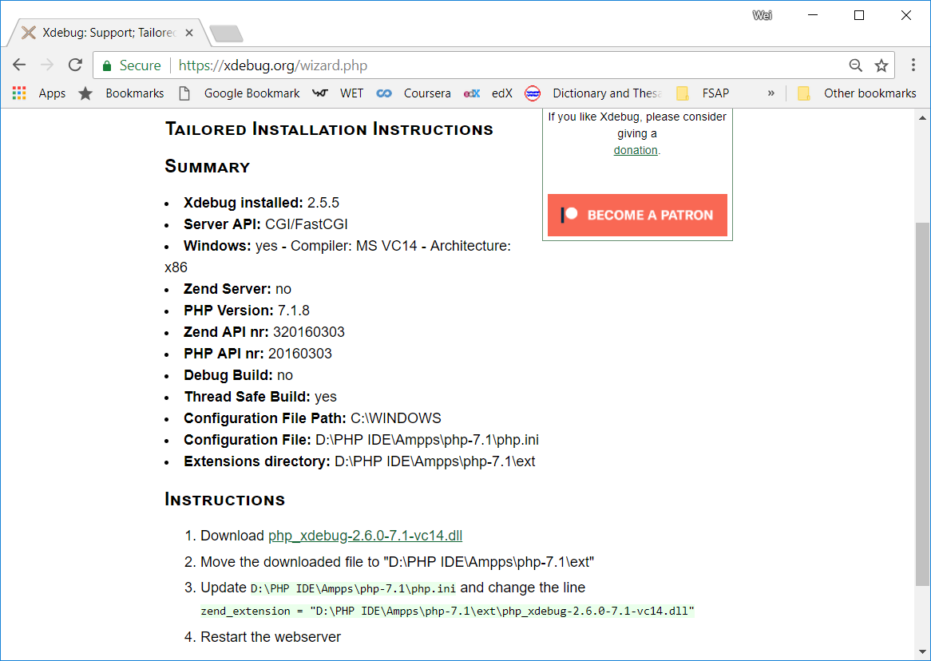

1. Following the instructions on the analysis result page to download and copy the .dll to the specified folder:

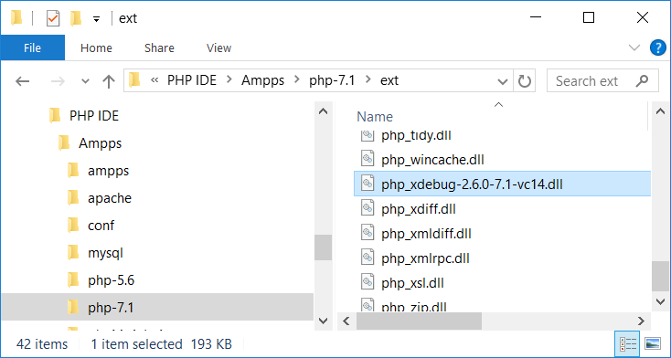

There are several **php.ini** configuration files inside different subfolders. Make sure you edit the one indicated on the analysis result page.

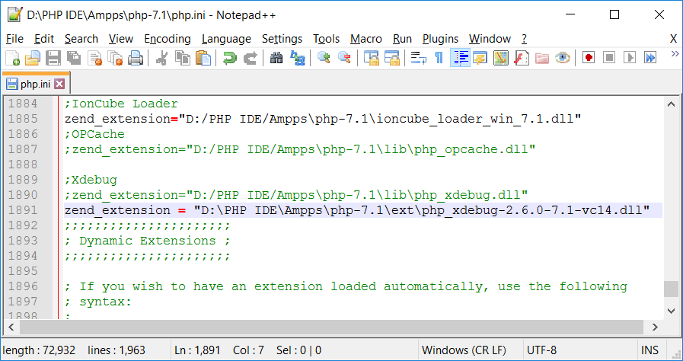

On php info page, search for Xdebug, you should see a configuration section of Xdebug settings.

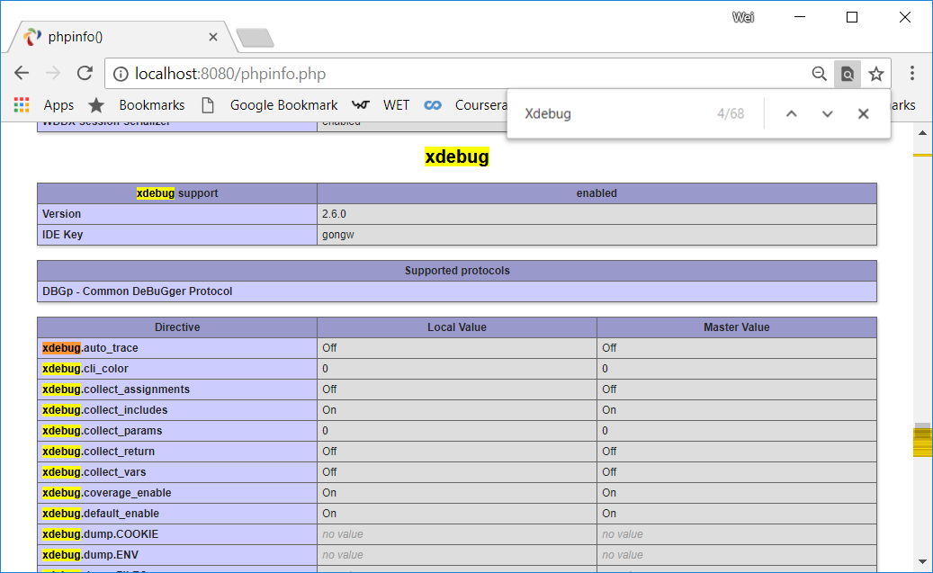

# Install NetBeans

NetBeans is one of the best open source development environments for a variate of programming languages. NetBeans PHP also includes two most popular PHP frameworks.

You can download NetBeans PHP installation file from the follow website:

<https://netbeans.org/downloads/>

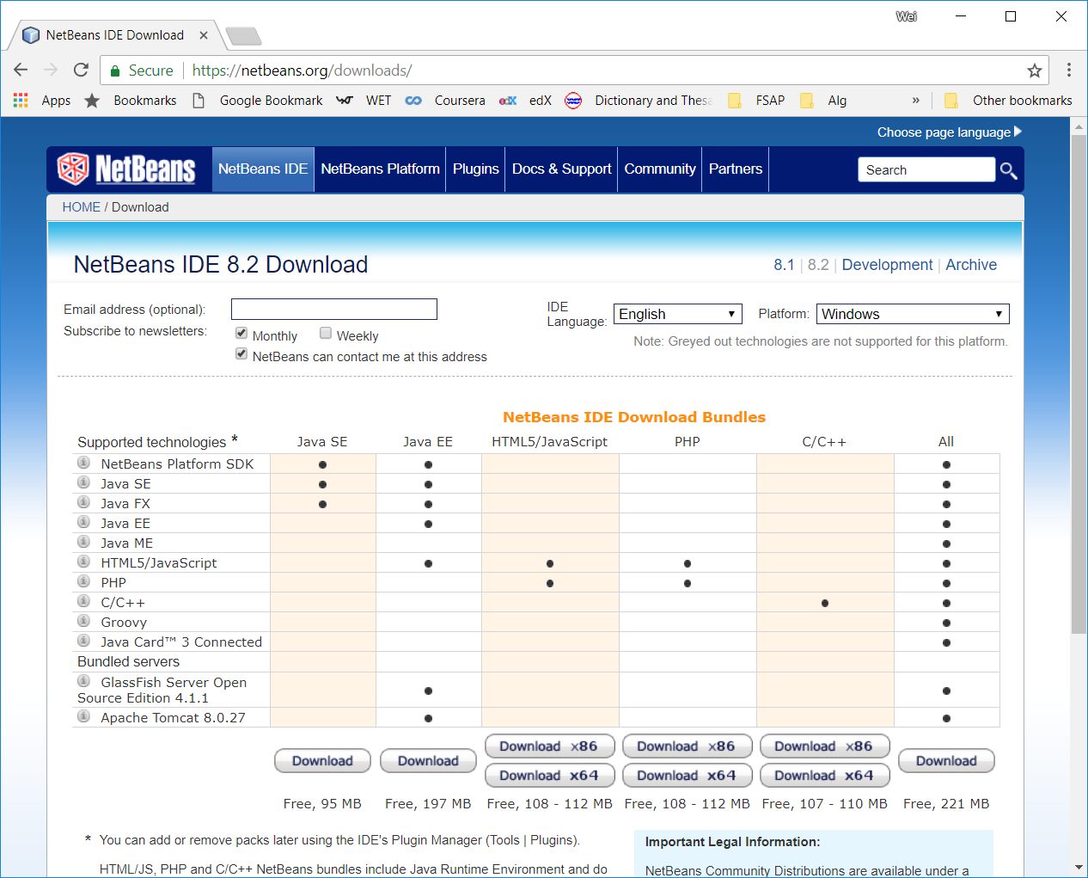

Once the download completes, run the installation file and follow the wizard to complete the installation.

# Integrate NetBeans and XDebug

1. Continue to edit the same **php.ini** file as in above to added the following lines

xdebug.remote_autostart=on

xdebug.remote_enable=on

xdebug.remote_enable=1

xdebug.remote_handler="dbgp"

xdebug.remote_host=localhost

xdebug.remote_port=9000

xdebug.remote_mode=req

xdebug.idekey="netbeans-xdebug"

As shown in the following screen capture:

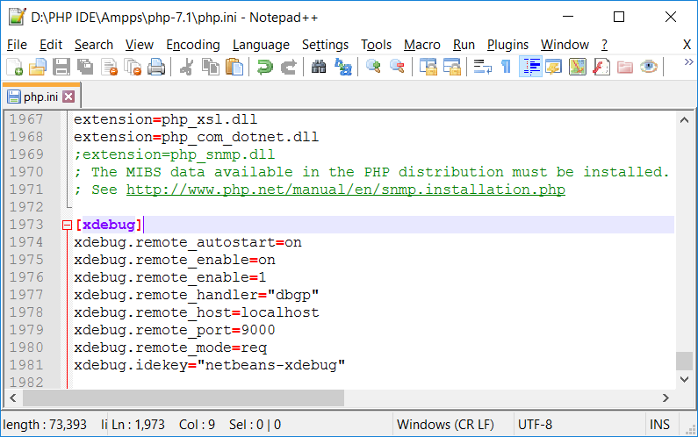

1. Start NetBeans, select menu **Tools > Options**. On the Options dialog, select **PHP** and then **Debugging** tab. Make sure the Debugger Port and Session ID are the same as entered in the php.ini file as above.

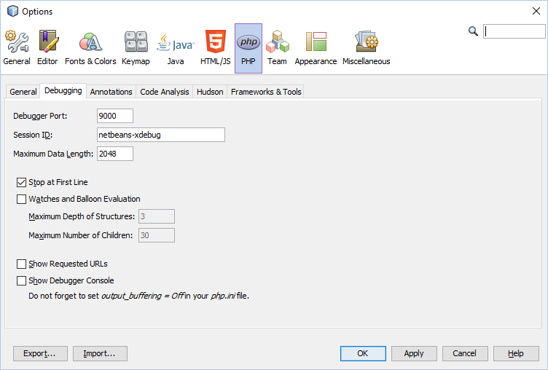

Explore this Options Dialog to see the options you have and set NetBeans work as you prefer. One of the settings you are likely to change is to select your preferred web browser to use with NetBeans:

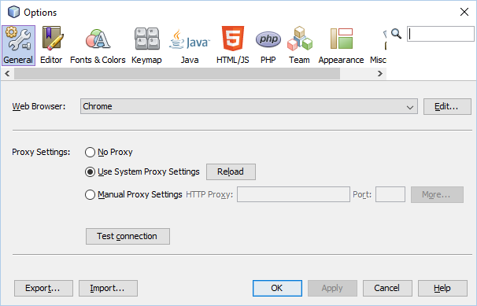

# Integrate NetBeans with MySQL Database

This step is optional. You can use NetBeans to perform some basic database operations, such as create DB tables, browser/create/delete/edit table data and running SQL statements, etc. However, we will use **phpMyAdmin**, a popular web-based MySQL administration tool, to manage the database used in this course. **AMPPS** installation includes **phpMyAdmin**. We will learn how to use phpMyAdmin later in the course.

Follow the steps below to integrate MySQL DB Server with NetBeans:

1. If not yet, start NetBeans. Select **Services** panel, right click on Databases and select **Register MySQL Server …**

Enter accept all default entries, and enter **mysql** as password.

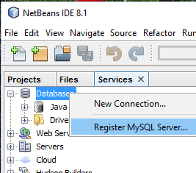

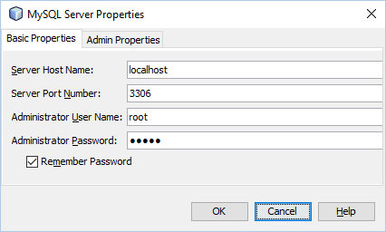

Assuming that the installed MySQL DB Server uses the default port **3306**. If you already have an instance of MySQL running on your laptop when you install AMPPS, the newly installed MySQL may not use this default port. To find out which port, MySQL server is listening, check **my.ini** file inside Ampps\mysql folder:

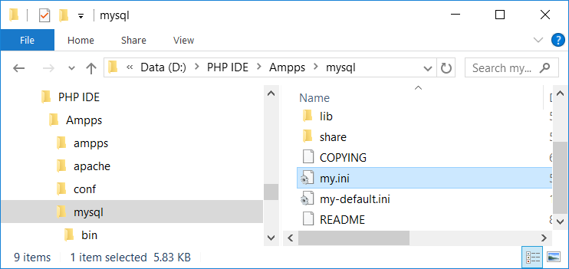

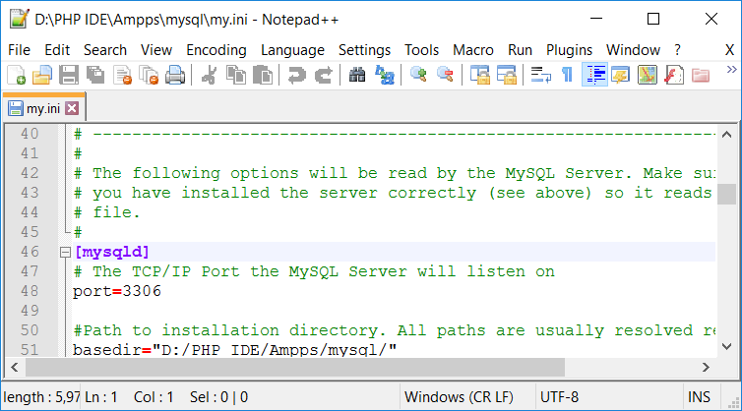

1. Righ click on MySQL Server at localhost:3306 and select

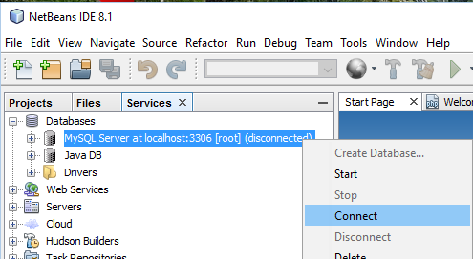

1. Expand MySQL Server at localhost:3306, you should see the following:

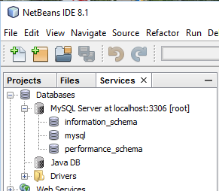

# Create Your First PHP Web Application

1. Start NetBeans (f not yet) and select menu item “File > New Project …”. On the New Project dialog, select **PHP** and **PHP Application**.

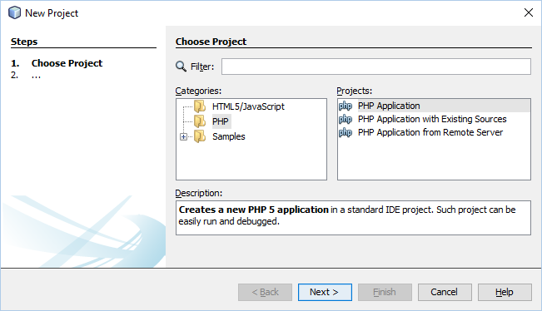

1. Enter **CST8257Lab1** as project name. Go to AMPPS’ document root (in my AMPPS installation, it is D:\PHP IDE\Ampps\www) and create a folder **CST8257Lab1**, set it as Source Folder (use Browse … button) of the project.

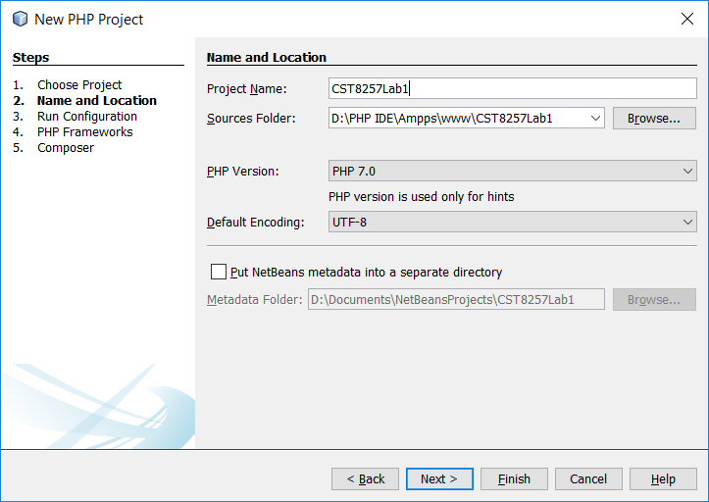

1. Make sure you enter the correct port number to the project URL (8080 in my case)

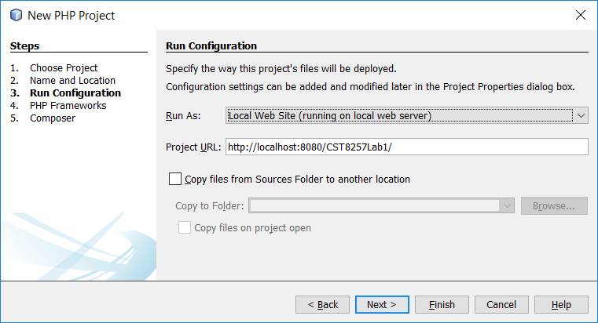

1. Skip the next two steps and click Finish.
2. Right click on the Source Files folder and select **New > PHP Web Page …**

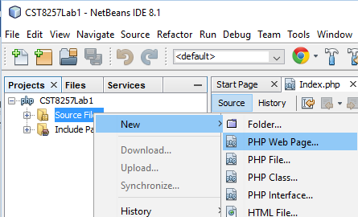

1. Enter Welcome as the file name and click Finish

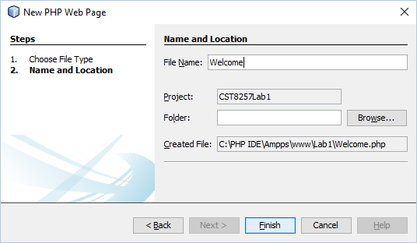

1. Edit the created Welcome.php page so that it looks as below:

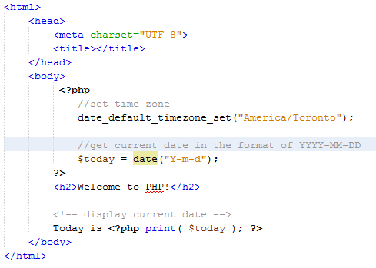

1. Right click Welcome.php and select Run. You should see your preferred web browser opens and displays the page Welcome.php.

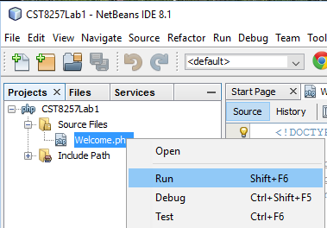 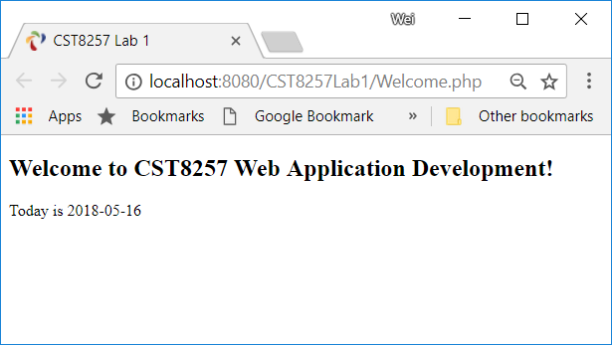

1. Right click on Welcome.php and select Debug, the execution starts and stops at the first php statement. You can step through php script to debug your php scripts.

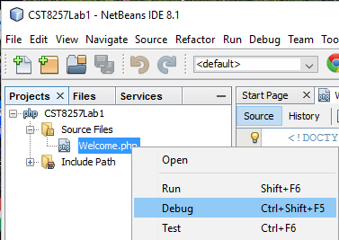

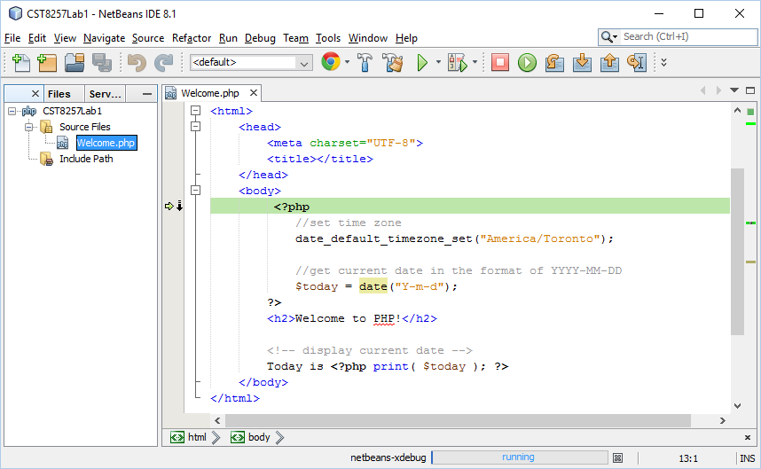

Execution breaks here

To find out more on NetBeans PHP go to:

<https://netbeans.org/features/php/index.html>

**End of Lab 1**

# Appendix 1 – Setup Visual Studio for PHP IDE

# Install AMPPS and XDebug

Install AMPPS and XDebug as above.

# Install PHP Tools for Visual Studio 2017

To develop PHP web applications using Visual Studio, you have to install **PHP Tools for Visual Studio** extension.

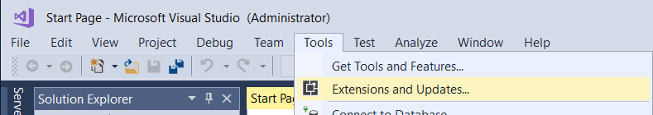

Select **Online > Visual Studio Marketplace**, Search for php in the search box, download **PHP Tools for Visual Studio 2017** from the search results

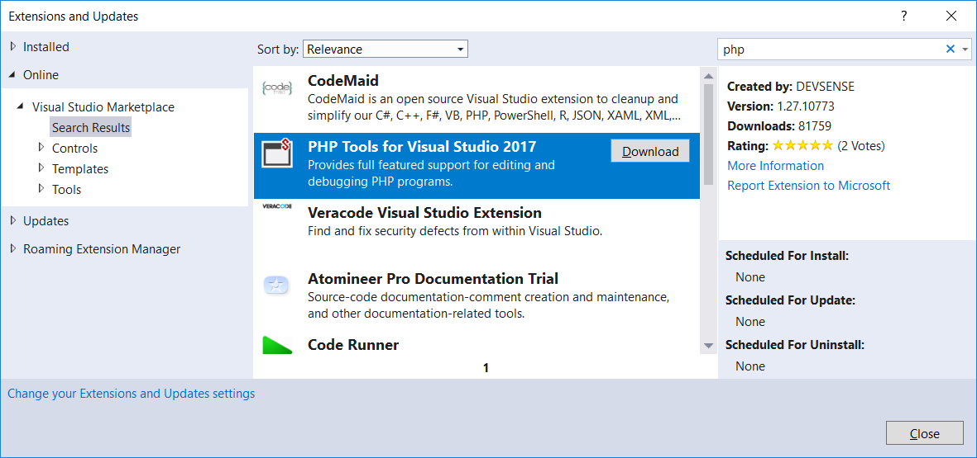

Once download complete, click Close button and exit Visual Studio, the extension installation will start.

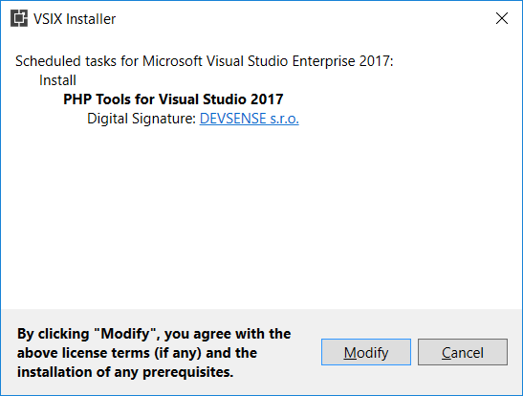

# Create your first PHP Web Application

Start Visual Studio and select menu item **File > New Project …**. In the New Project dialog, select **PHP > PHP Web Project** and specify the project name and location.

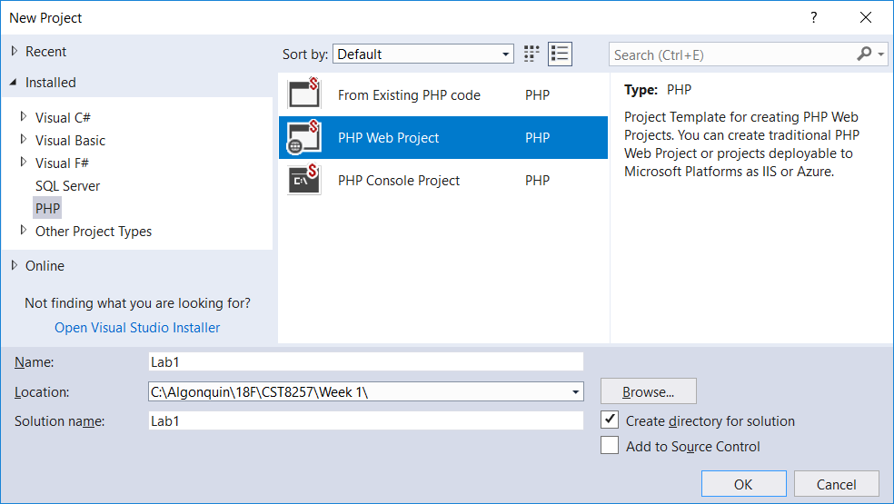

Select Empty Web Site:

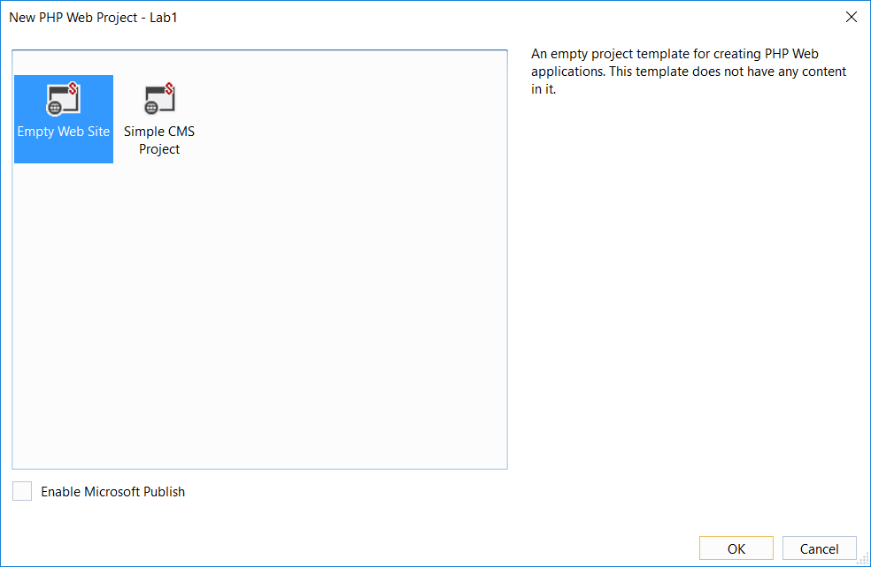

Visual Studio will create a website default PHP file **index.php** in the project:

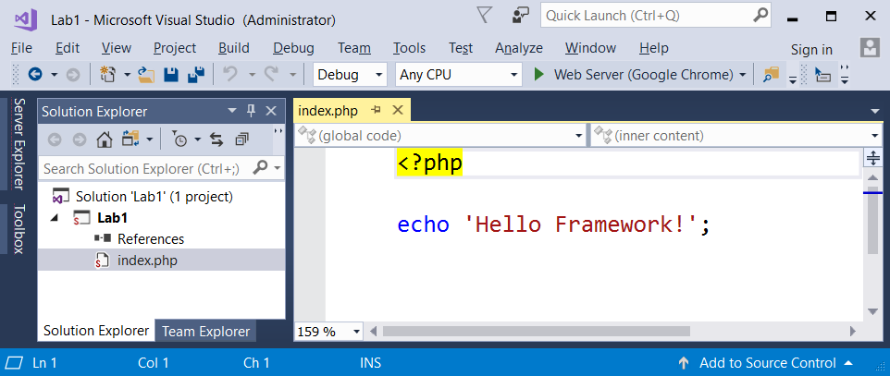

# Install PHP Extension to IIS Web Server

Click menu button **Web Server (…)** to start debugging the page. For the very first time, PHP Tools for Visual Studio detects that you have not installed PHP extension to IIS (or IIS Express included with the Visual Studio). It prompts you for what to do next, you can let **PHP Tools for Visual Studio** automatically download and install PHP extension to IIS together with its corresponding Xdebug.

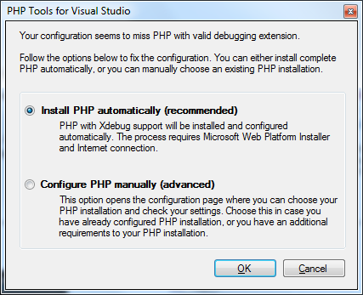

Once completing PHP extension installation, the default browser will start and show the page **index.php**:

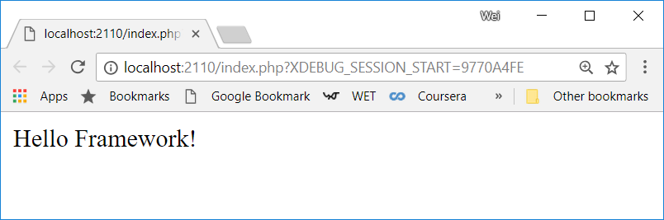

To add a new php page, Welcome.php

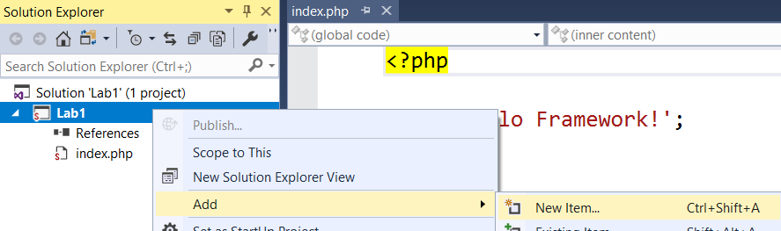

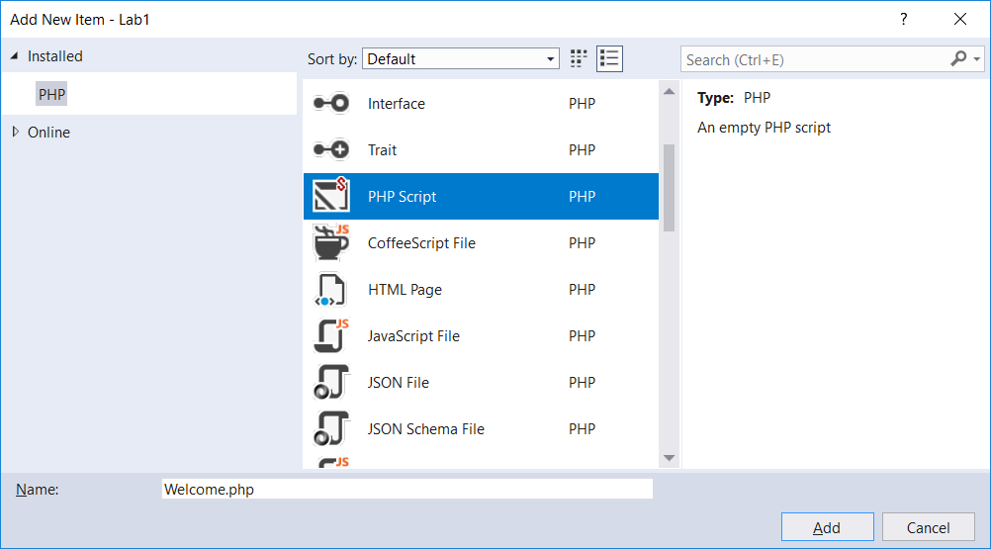

Replace the contents of **Welcome.php** with the following:



Set Welcome.php page as the project’s start page

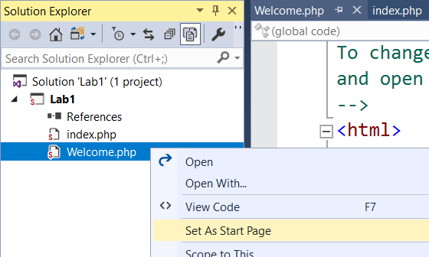

Add break points, click menu button **Web Server (…)** to start debugging Welcome.php page.

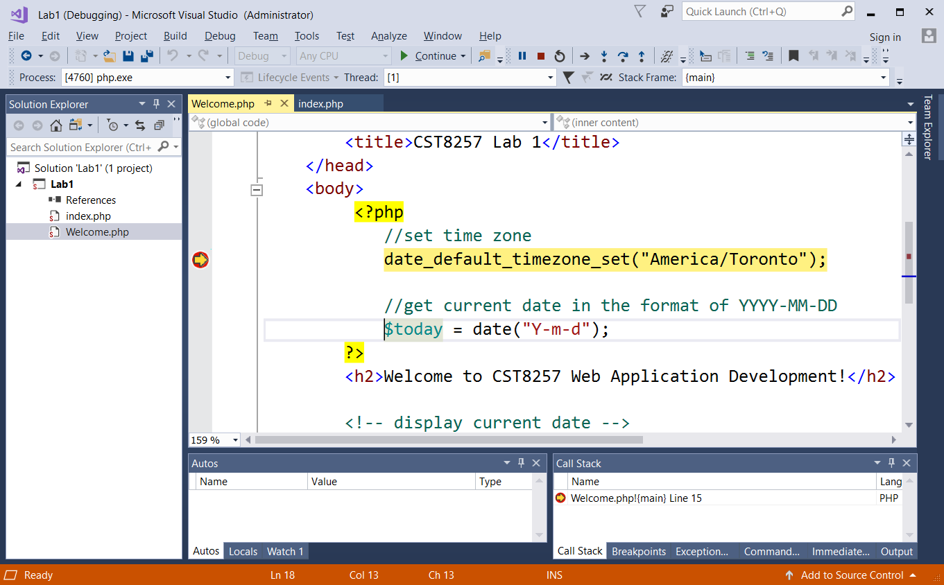

Let the execution continue, the default browser will start and display the page:

